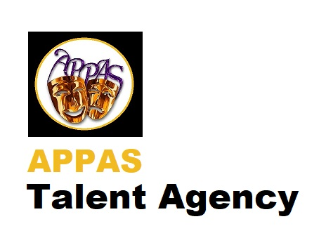
AGREEMENT FORM
(Version 3 November 2019)

Agreement between APPAS Talent Agency of Harmony Grange, Grendon Road, Edgcott, Aylesbury, HP18 0TN.
Sign for/on behalf of APPAS Talent Agency: (Enter name here).
And
Performer: (Enter name here).
Date of Birth:
Address:

Postcode:
Date:
Day Month Year

APPAS Talent Agency are a subsidiary of The Adele Peters Performing Arts School Ltd, a registered Company in England and Wales, whom shall be referred in this agreement herein as APPAS.
The Performer is the artiste listed above and signing this agreement as the Performer with APPAS.
The Client is a person(s) including legal entity / company offering paid or unpaid work to the Performer.

Performer Signature: Agent Signature:
Date: Date:
- The Agreement
This agreement is between the Performer and APPAS Talent Agency.
The Performer having the legal right to enter into this agreement or in case of a minor, agreed by the legal guardian with Parental responsibility and legal right to enter into this agreement.
The length of this agreement will be continuous until the Performer gives three months’ notice of intention to terminate this agreement and a signed agreement from APPAS Talent Agency confirming the end of this agreement has been received. APPAS Talent Agency will continue to collect commission on work gained through the Performer’s time with APPAS Talent Agency at the agreed rate, as set out below. Any relevant royalties and proceeds of merchandising and any other income will be obtained in perpetuity.
On signing this agreement APPAS Talent Agency will undertake the appointment as the Performer’s agent. The Performer may enter into agreements with other parties but must notify APPAS Talent Agency of all parties with which an agreement has been entered.
Any and all agreements in pre-existence of this document shall be acknowledged in writing by APPAS Talent Agency before signing or will remain the responsibility of the Performer.
The Performer agrees to keep APPAS Talent Agency updated to their address and contact details whilst under this agreement and for a period of three years beyond.
APPAS Talent Agency will charge an annual promoting fee of £25 and will deduct 15% from all earnings, (including gifted items at APPAS’ discretion). The Performer will ensure all payments are made directly to APPAS Talent Agency. The payment will be the forwarded to the Performer less the APPAS Talent Agency commission and value added tax will also be removed at such times as APPAS Talent Agency becomes VAT registered. In case of International payments, all taxes will be deducted accordingly in line with law and legislation. A member of APPAS Talent Agency staff can attend casting/booking or booking with a young Performer subject to availability. This is chargeable and will be agreed by separate agreement including travel expenses.
- APPAS Talent Agency do not guarantee any work or auditions.
- Should the Performer be offered a job / audition or other work, the Performer must confirm that they are willing to attend.
- If agreeing to attend, there must be 100% attendance unless agreed with APPAS Talent Agency and the client.
- The contract must be upheld between the client and Performer.
- All contracts between the client and the Performer will have no legal obligations from APPAS Talent Agency except for the deduction of the commission.
- The Performer will source their own travel arrangements and accommodation if required.
- Punctuality, professionalism and manners must be upheld at all times.
- Should the Performer not want to be offered auditions / work they must inform APPAS Talent Agency immediately.
- The Performer will, at all times, act as an ambassador for APPAS Talent Agency and/or The Adele Peters Performing Arts School and will not mention, pass comment or refer to APPAS Talent Agency or its staff in a derogatory manner to anyone for any reason.
- The Performer must contact APPAS Talent Agency before unexpectedly leaving any venue except in life threating or unsafe situations.

Performer Signature: Agent Signature:
Date: Date:
2. GDPR
Personal Information
If you are unhappy, disagree or do not understand the personal information section below. You must not enter into this agreement.
Personal information will be held with your permission by the APPAS Talent Agency / Adele Peters Performing Arts School Ltd. In order to attract castings, parts and performance opportunities we will share some, part or all of your information with third parties at our discretion. We will contact you by e mail, phone or text with the details of communications received and other possible connections to work either paid or non-paid. This will also include all APPAS Talent Agency promotional material.
Your Information will be retained, until you terminate this contract by the agreed process set out in this agreement and you have received termination letter from APPAS Talent Agency.
- Safety
- All Performers must take appropriate cautions whilst entering into unknown situations. We will do everything to ensure a casting is safe for ALL our Performers before submitting their details for a casting/audition or sending out casting/audition invites. However, should a casting/audition not be as advertised upon arrival, you should contact us immediately.
- APPAS Talent Agency must know when you are attending auditions / casting or bookings.
- APPAS Talent Agency must be kept informed of where you are at all times including any changes to your schedule.
- Children must not be left unattended without verified licenced chaperones and a note of their name and licence must be taken.
- Do not enter into any agreement, any further meeting or change of venue until you have agreed with APPAS Talent Agency that this is the appropriate course of action.
- Under no circumstances are Performers to be asked to remove clothing or act in a manner they feel inappropriate. If this happens for any reason the Performer must not continue and consult with APPAS Talent Agency immediately.
- Children will under no circumstances be asked to smoke or any other activity detrimental to their health.
- Performers must be aware of all text provided to them prior to attending any booking / audition / casting including learning lines etc.
4. Spotlight
A Performer agrees to have their details placed on the Spotlight forum at cost to them.
APPAS Talent Agency will not profit from your registration and will remain your point of contact for Spotlight to contact you.

5. Photographs and Other Media
Any and all photographs / videos or media taken by or presented to APPAS Talent Agency shall remain the property of APPAS Talent Agency along with the right to use in any way APPAS Talent Agency feels appropriate. Performers take responsibility of ensuring they have the correct permissions for all media presented to APPAS Talent Agency.

Performer Signature: Agent Signature:
Date: Date:

I, (Performer or Parent / Guardian of Performer if under 18), hereby agree with the Terms and Conditions as laid out in Section 1 – 5 above) and confirm that I understand that, should any of the above Terms be broken either by the Performer or APPAS Talent Agency, then the Agreement will automatically become null and void. Any existing contracts of works will continue to remain subject to our commission fees until the completion of such contracts.

Performer

Signed:

Print:

Date:

IF UNDER 18 A PARENT / GUARDIAN MUST ALSO SIGN

Parent /Guardian

Signed

Print

Date:

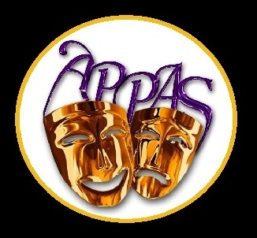
APPAS Talent Agency (Representative)

Signed

Print

Date:
TALENT AGENCY

